S Y N O P S I S

On

**“OBSTACLE AVOIDING SWARM ROBOTICS”**

Submitted in partial fulfillment of the requirements for the degree of

Bachelor of Engineering in Electronics& Telecommunication Engineering

By

MISS.Pooja Ram

Under the guidance of

Prof. Sharad Wagh



Department of Electronics& Telecommunication

**Vishwaniketan’s**

**Institute of Management Entrepreneurship & Engineering Technology (iMEET)**

**UNIVERSITY OF MUMBAI**

**Academic Year 2015 – 16**

**Vishwaniketan’s**

**Institute of Management Entrepreneurship & Engineering Technology (iMEET)**

**UNIVERSITY OF MUMBAI**

**Academic Year 2015 – 16**



**SYNOPSIS OF PROJECT WORK**

Name of the Dissertation: OBSTACLE AVOIDING SWARM ROBOTICS

Student’s Name: POOJA SUDARSHAN RAM

Class:T.E EXTC

College:VISHWANIKETAN’S iMEET

Semester: V

University Registration Number:

Date of Registration

Exam Fee Receipt No.:

Name of the Guide: Prof. SHARAD WAGH

Project guide Student

Prof. Mr. Sharad Wagh

LIST OF CONTENT

|  |  |  |
| --- | --- | --- |
| Sr No. | Name | Page No. |
| 1 | Objective | 4 |
| 2 | Introduction | 4 |
| 3 | Schematic of swarm robots | 5 |
| 4 | Construction and working | 6 |
| 5 | Hardware and software required | 7 |
| 6 | Advantages | 7 |
| 7 | Applications | 7 |
| 8 | Conclusions | 8 |
| 9 | References | 8 |
|  |  |  |
|  |  |  |
|  |  |  |

1. OBJECTIVE

Our main interest in this project is to introduce swarm robots to how to reach a certain goal while maintaining formation and avoiding obstacles.

2. INTRODUCTION

Swarm robots are required to explore and search large areas. In order to cover largest possible area while keeping communications, robots try to maintain a formation while moving. Obstacle avoidance is an extremely important task for swarm robotics as it saves robots from hitting objects and being damaged.

This work could teach robots how to move in different environments with 2.5% obstacles coverage while keeping their connectivity more than 82%. Percentage of robots reached the goal was more than 97% in 70% of the environments and more than 90% in the rest of the environment.

**4. Schematic of swarm robotics**

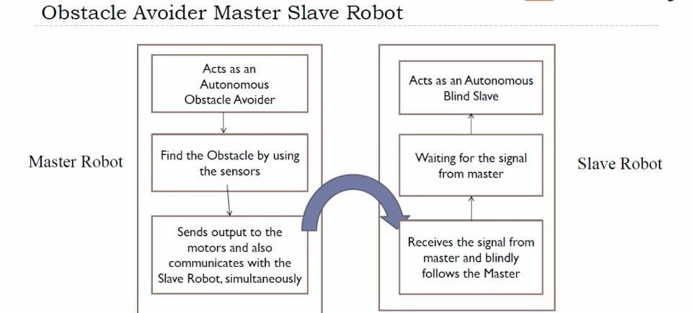

**5. CONTRUCTION AND WORKING :**

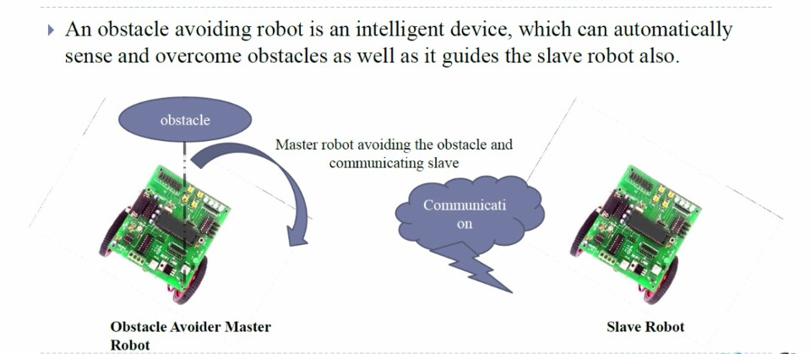

**In this obstacle avoiding sensors (IR SENSORS) will be used two for each robot. As the master robot detects the obstacle it transmits that information to the slave robot, so here communication between the robots will be seen as shown in the fig above.**

**The block diagram below shows the working of IR sensors in detecting and avoiding the obstacle.**

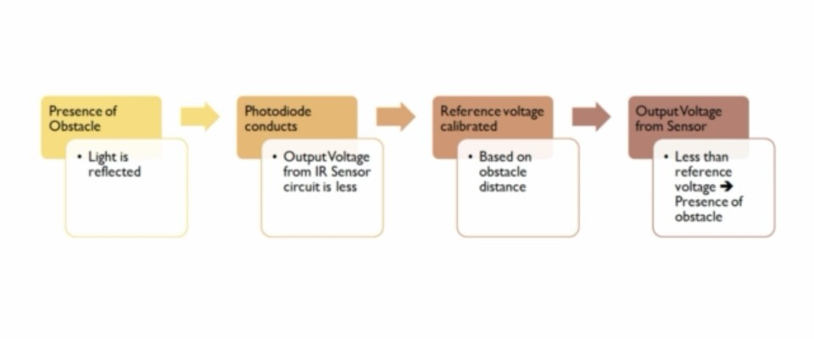

**6. HARDWARE AND SOFTWARE REQUIRED**

Swarm Robotics - Master Robot Components

* 89S52 Development Board
* RF Transmitter and Encoder Module
* USB-ASP Programmer
* Chassis
* Wheels
* DC Motors
* Wire stripper
* Screwdriver
* Connecting wires
* 2 9V batteries

Swarm Robotics - Slave Robot Components

* 89S52 Development Board
* RF Receiver and Decoder Module
* DC Motors
* Chassis
* Wheels
* 2 9V batteries
* KEIL UVISION SOFTWARE
* USP-ASP DRIVER

**8. ADVANTAGES**

* These are very efficient.
* These technique reduces the man power.
* Time consumption is less.
* Very accurate.
* Can be used to do the task that are hazardous for human.
* Can be used in various applications.

**9. APPLICATIONS**

* Disaster rescue missions
* Demand cheap designs.
* Mining
* Agricultural
* Military

**10. FUTURE DEVELOPMENT**

* We can add camera modules to capture images and videos of the surroundings where the robot are sent.
* We can modify this project to stairs walking swarm robots.
* It can also be Bluetooth controlled swarm robot.

**11. CONCLUSION**

* We have discussed several different approaches to both robot swarm formation control and robot

obstacle avoidance

**12. REFERENCES**

ISSN: 2319-8753 International Journal of Innovative Research in Science, Engineering and Technology, Vol. 3, Issue 7, July 2014.